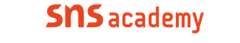

An international CBSE Fingerprint School
Coimbatore

Chapter No | Topics | Month
11,12,13 | Relational Databases,  Simple Queries in SQL  Table creation &Data Manipulation Commands | Feb,march
14  3 | Grouping Records,Joins in SQL  Working With Functions | April
4 | File Handling | June
9,15 | Data structure(Stack)  Interface Python with Mysql | July
10 | Communication and Network Concepts | August
10 | Communication and Network Concepts,Board Projects. | September

